**Project #3 – A Real Application Parallel Challenge**

Hyun-Taek Oh

[ohhyun@oregonstate.edu](mailto:ohhyun@oregonstate.edu)

8 May 2024

1. **What machine you ran this on?**

The program was conducted on a Predator HELIOS 300 (2022).

CPU: 12th Gen Intel(R) Core™ i9-12900H  
Motherboard: Mainboard PH315-55 Intel Ci912900H GN20-E6  
Memory: 16GB DDR5

1. **What operating system you were using?**

Operating System: Windows 11 Home

1. **What compiler you used?**

Compiler: g++ (GCC) 4.8.5 20150623 (Red Hat 4.8.5-44)

1. **The table of performance data**

|  |  |  |  |  |  |  |  |  |  |  |
| --- | --- | --- | --- | --- | --- | --- | --- | --- | --- | --- |
| **NUMCAPITALS**  **NUMT** | **2** | **3** | **4** | **5** | **10** | **15** | **20** | **30** | **40** | **50** |
| 1 | 14.203 | 15.964 | 21.089 | 22.388 | 25.375 | 29.66 | 28.738 | 33.881 | 39.524 | 38.424 |
| 2 | 5.454 | 6.897 | 17.172 | 10.819 | 21.245 | 30.9 | 31.899 | 39.916 | 51.904 | 53.344 |
| 4 | 3.957 | 9.5 | 7.006 | 8.584 | 18.012 | 28.681 | 39.457 | 56.649 | 72.645 | 83.62 |
| 6 | 3.283 | 4.148 | 5.206 | 6.275 | 13.736 | 21.679 | 29.84 | 48.029 | 67.482 | 90.965 |
| 8 | 3.219 | 3.694 | 4.929 | 6.009 | 12.624 | 17.773 | 23.433 | 40.412 | 56.935 | 68.754 |

The table above shows the relationship between the number of threads and capitals. The floating-point numbers denote the performance depending on the number of threads and capitals (megaCityCapitalsPerSecond). When the number of capitals increases, most of the performances also gradually increase, implying that the number of threads can affect the performance. Unlike our expectation, the increase in the number of threads does not necessarily guarantee better performance. As can be seen, When NUMCAPITALS is 50, six-threads case shows the best performance.

1. **A graph of performance vs. NUMT with the colored curves being NUMCAPITALS.**

The graph above shows the performance of the number of threads when the number of capitals is different. In general, all the threads show the higher performance if the number of capitals increases more and more. In the graph, six-threads case has the best performance, which is nearly 90 megaCityCapitalPerSecond. When the number of capitals is small, the performance of the least number of threads, which is just one thread, results the best performance, displaying 14 megaCityCapitalPerSecond, and is even better than the performance of six or eight threads. This implies that there are some factors affecting the performance when the number of works is small enough.

1. **A graph of performance vs. NUMCAPITALS cities with the colored curves being NUMT.**

As shown in the graph above, it shows the performance of the number of capitals when the number of threads is different. Until reaching 40 capitals, four-threads have best performance. When the number of capitals is 50, however, six threads are the best case, which has approximately 90 megaCityCapitalsPerSecond.

1. **What you discovered by doing this? What patterns are you seeing in the graphs?**

Two graphs above means that the increase in the number of threads will not always guarantee the best performance. If the number of threads guarantee the better and even best performance, these graphs are contradiction. In the lecture note “Data Composition”, we may guess why this happens. One of the reasons this phenomenon occurs may be false sharing between cores. Another reason is that, as shown in two graphs, if I am not utilizing enough cores, then I am not bringing enough compute power to bear. On the other hand, if I am utilizing too many cores, then each core doesn’t have enough to do and too much time is being spent getting values from the memory that another core is computing with. These patterns can be explained with the performance graphs.

1. 텍스트, 메뉴, 번호, 평행이(가) 표시된 사진

   자동 생성된 설명텍스트, 번호, 평행, 메뉴이(가) 표시된 사진

   자동 생성된 설명텍스트, 번호, 평행, 라인이(가) 표시된 사진

   자동 생성된 설명**[Extra Credit] When you are done computing the final longitudes-latitudes of the NUMCAPITALS, go through the list of cities and print the name of the city that is closest to each capital’s longitude-latitude.**

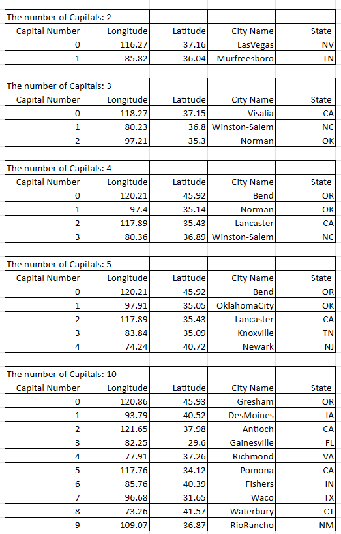

The pictures above show the number of Capitals, Capital Number, Longitude, Latitude, City Name, and State. The number of Capitals are 2, 3, 4, 5, 10, 15, 20, 30, 40, and 50, and Capitals are randomly chosen by Ranf() function, which generates arbitrary integer number. The closest cities are selected by the Capital’s longitude and latitude, which are the average of nearby cities.